GPU Computing: Assignment 2

**Task (1)**

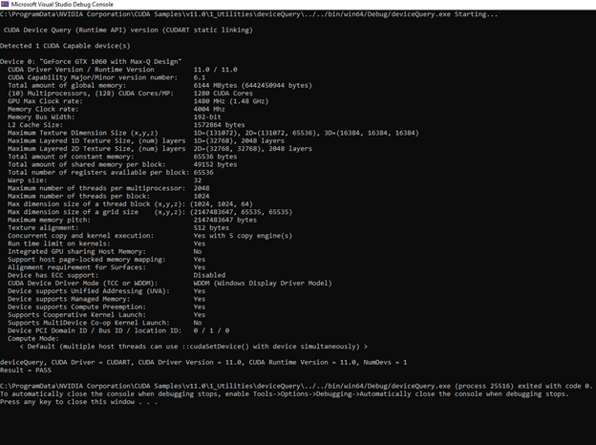

The results shown above represent the local device we are using and were obtained by running DeviceQuery on Visual Studio.

**\*All of the following tests were performed using matrices sizes A(2000x1500) and B (1500x2300) to exploit parallelism advantage.**

**\*Host time only accounts for the multiplication function and not memory allocation and initializations overhead because the O(n3) for loop is dominant and also because these steps are both necessary for the host and device.**

**Task (2)**

*For 4x4 blocks:*

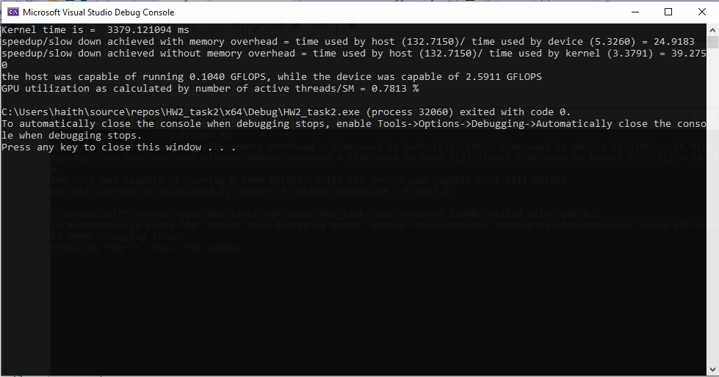

*For 8x8 blocks:*

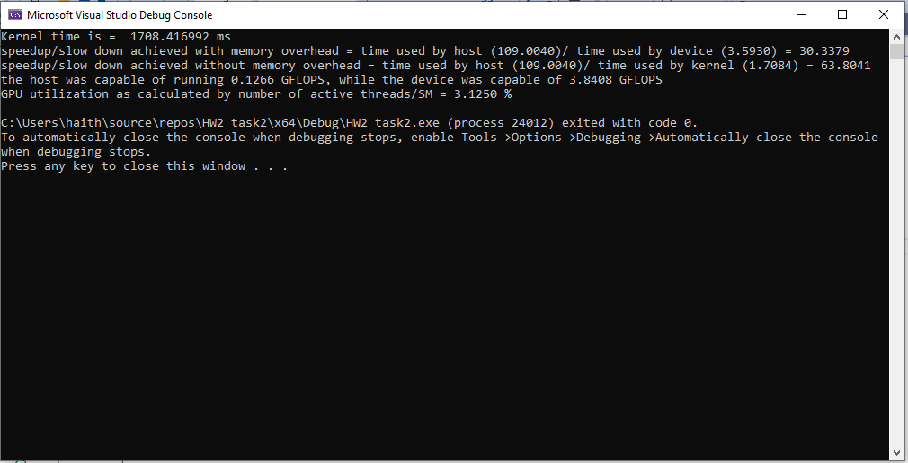

*For 16x16 blocks:*

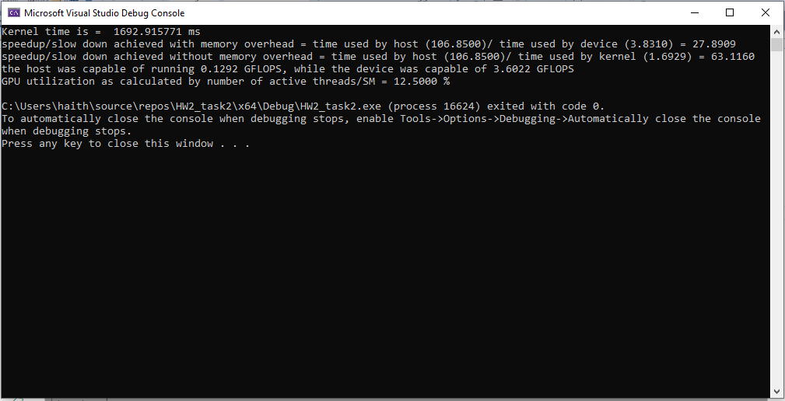

*For 32x32 blocks:*

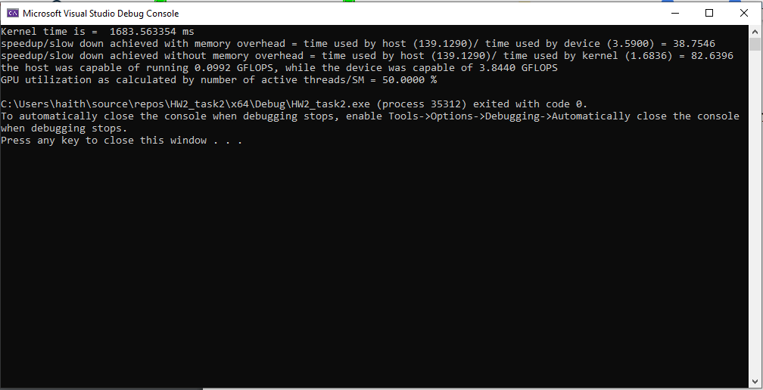

**Task (3)**

*For 4x4 Tiles:*

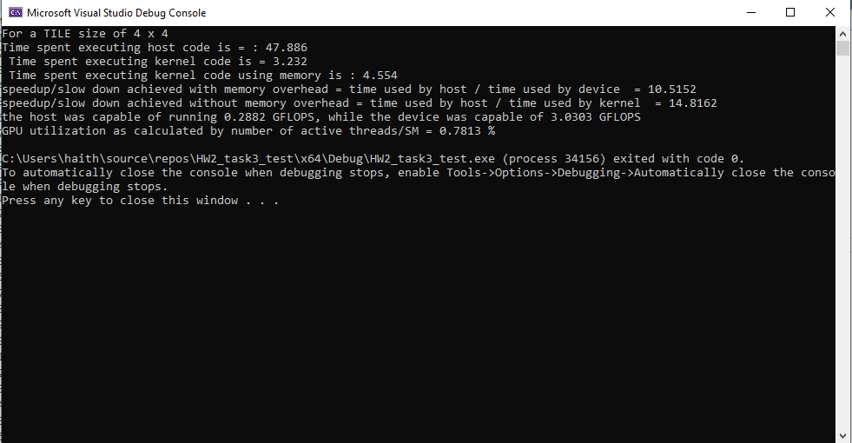

*For 8x8 Tiles:*

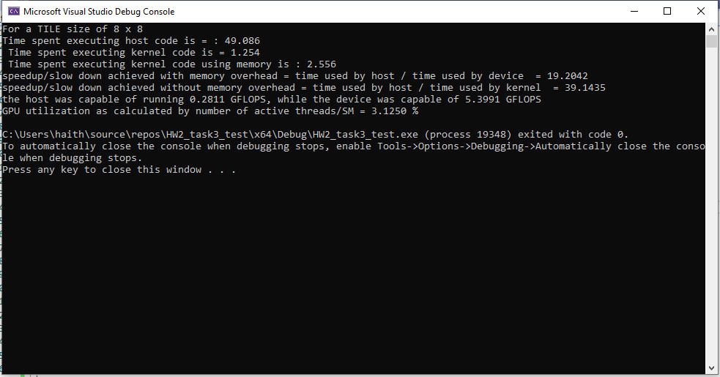

*For 16x16 Tiles:*

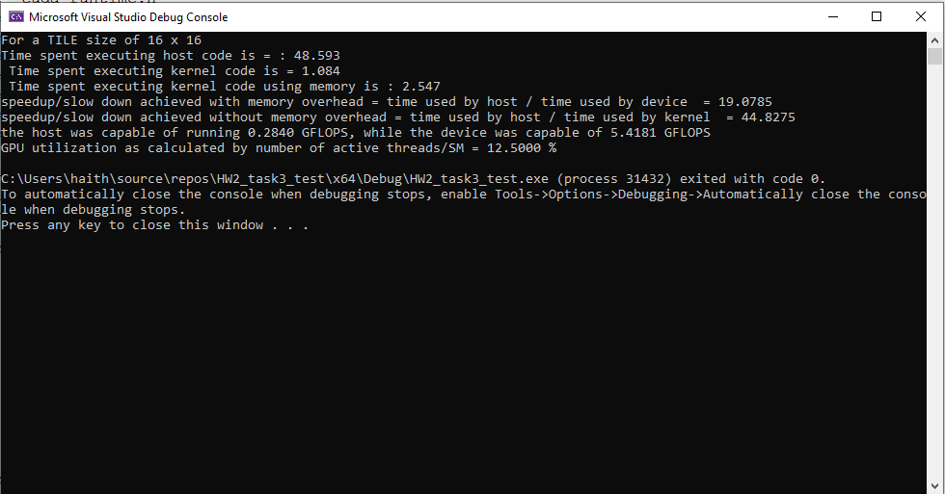

*For 32x32 Tiles:*

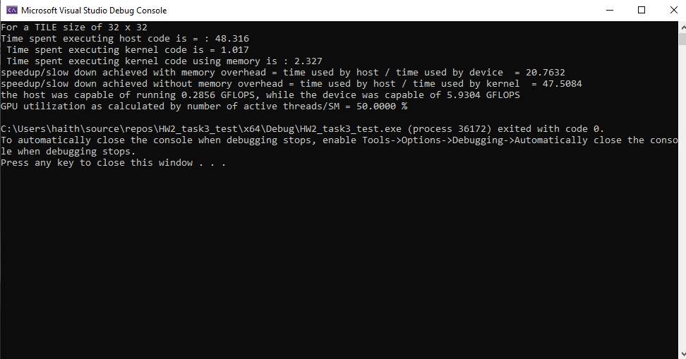

**Task (4): with increased thread granularity**

*For 4x4 Tiles:*

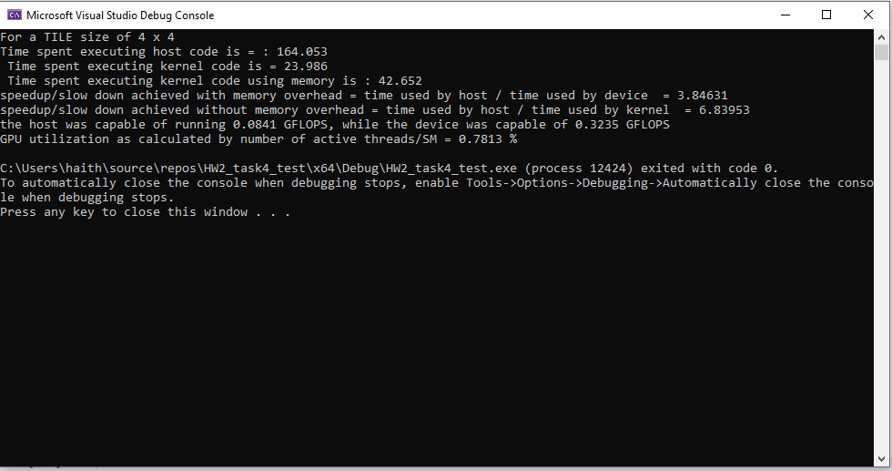

*For 8x8 Tiles:*

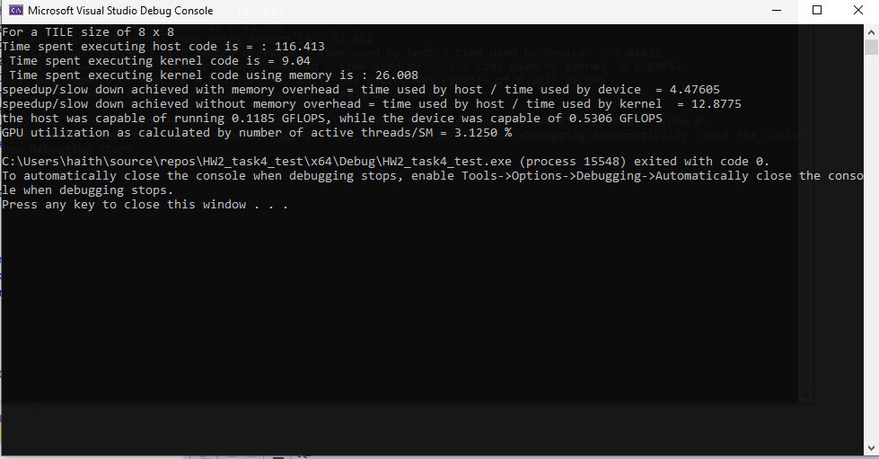

*For 16x16 Tiles:*

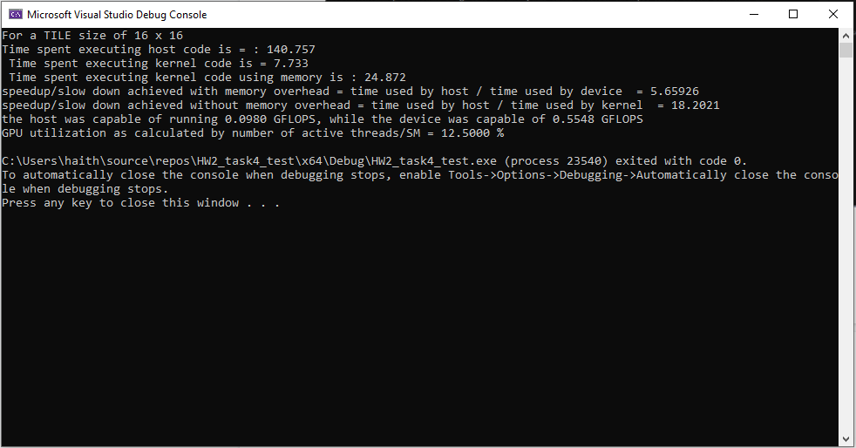

*For 32x32 Tiles:*

